1st December 2025

Dear Parents, Carers and guests,

You are warmly invited to attend our Christmas performance and end of term celebration on Thursday 11th December at 1:30pm, the performance begins at 1:45pm.

Our sixth form will be performing in their music groups and then celebrating the end of term after. This event will be hosted in the lounge at Oakmere road, where refreshments will be served, and our businesses will showcase their festive items available for purchase on the day.

Please let us know how many guests you would like to attend by filling in the reply slip below and returning it to school by 4th December 2025.

Yours sincerely
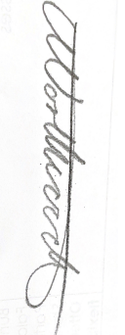
Kate Northwood
Head of Sixth Form

--------------------------------------------------------------------------------------------------------------------------------
Sixth Form Christmas Performance 11th December 2025 – Please return to Kate Northwood

Young person’s name: _________________________________ Class:__________________________
We are able/are not able to attend (delete as applicable) on the 11th December 2025
We would like (number) ____ adult tickets and (number) ____ child tickets.

