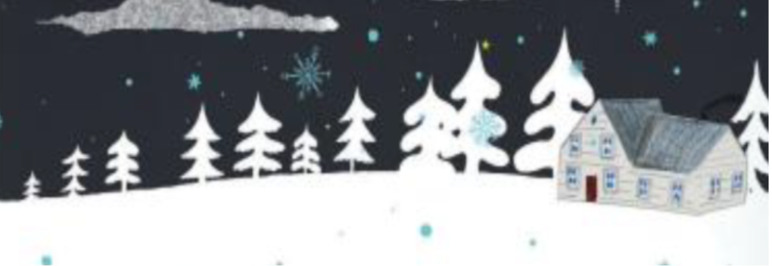
1st December 2025

Dear Parents, Carers and Guests,

You are warmly invited to attend our Christmas performance of ‘Over and under the Snow’ on Tuesday 9th December 2025.

Classes will be performing in groups and performances will last for approximately 30 minutes. Please see the performance schedule attached where you will find information regarding the allocated performance time for your child’s class.

Please let us know how many guests you would like to attend by filling in the reply slip below and returning it to school by 4th December 2025.

Yours sincerely
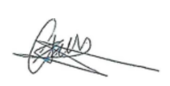
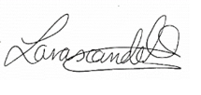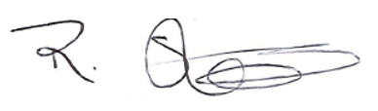
The Creative Arts Team
--------------------------------------------------------------------------------------------------------------------------------
Secondary Christmas Performance 9th December 2025 return to the school office by 4th December 2025

Child’s name: __________________________________ Child’s Class: __________________
We are able/are not able to attend (delete as applicable) on the 9th December 2025
We would like (number) ____ adult tickets and (number) ____ child tickets.
Please check the performance schedule attached for your child’s group and circle the relevant group below:

Group A Group B

Performance Schedule – 9th December 2025

Time | Group
1:15 pm | Group A Parents Arrive
1:30 pm | Welcome Group A Parents
 | Dormouse
 | Hedgehog
 | Pool Frog
2:00 pm | Goodbye Group A Parents
1:45 pm | Group B Parents Arrive
2:00 pm | Welcome Group B Parents
 | Badger
 | Otter
 | Squirrel
2:30 pm | Goodbye Group B Parents

