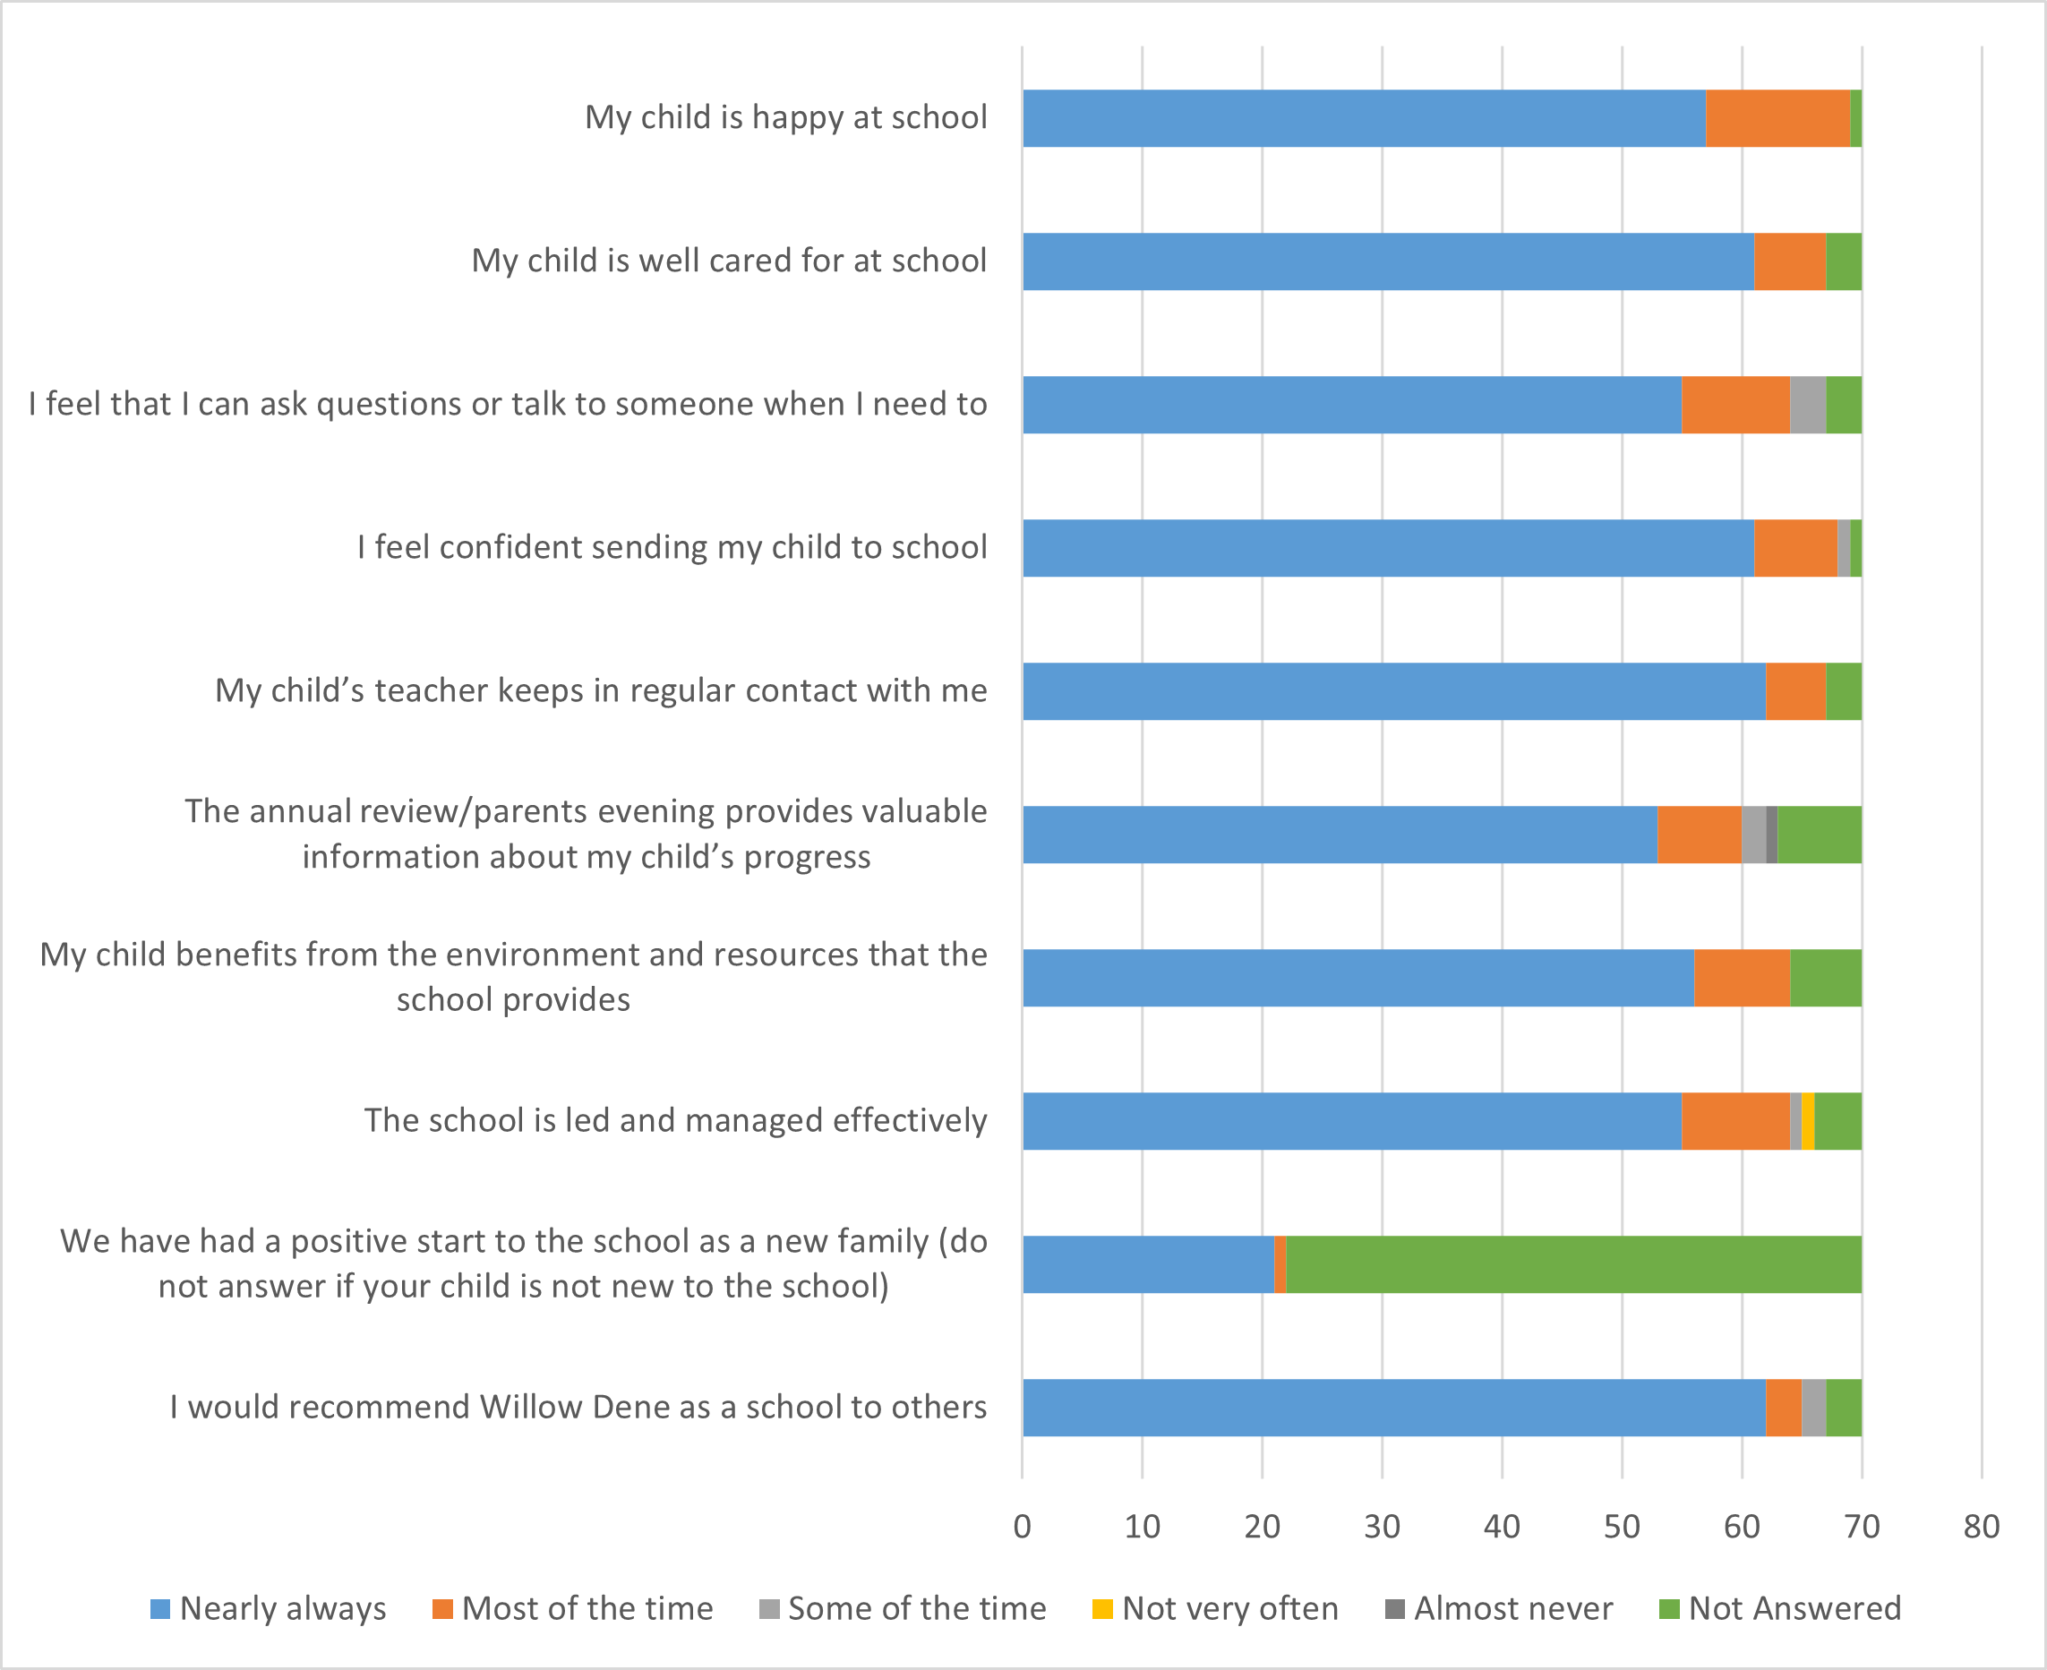
We received 70 responses in total
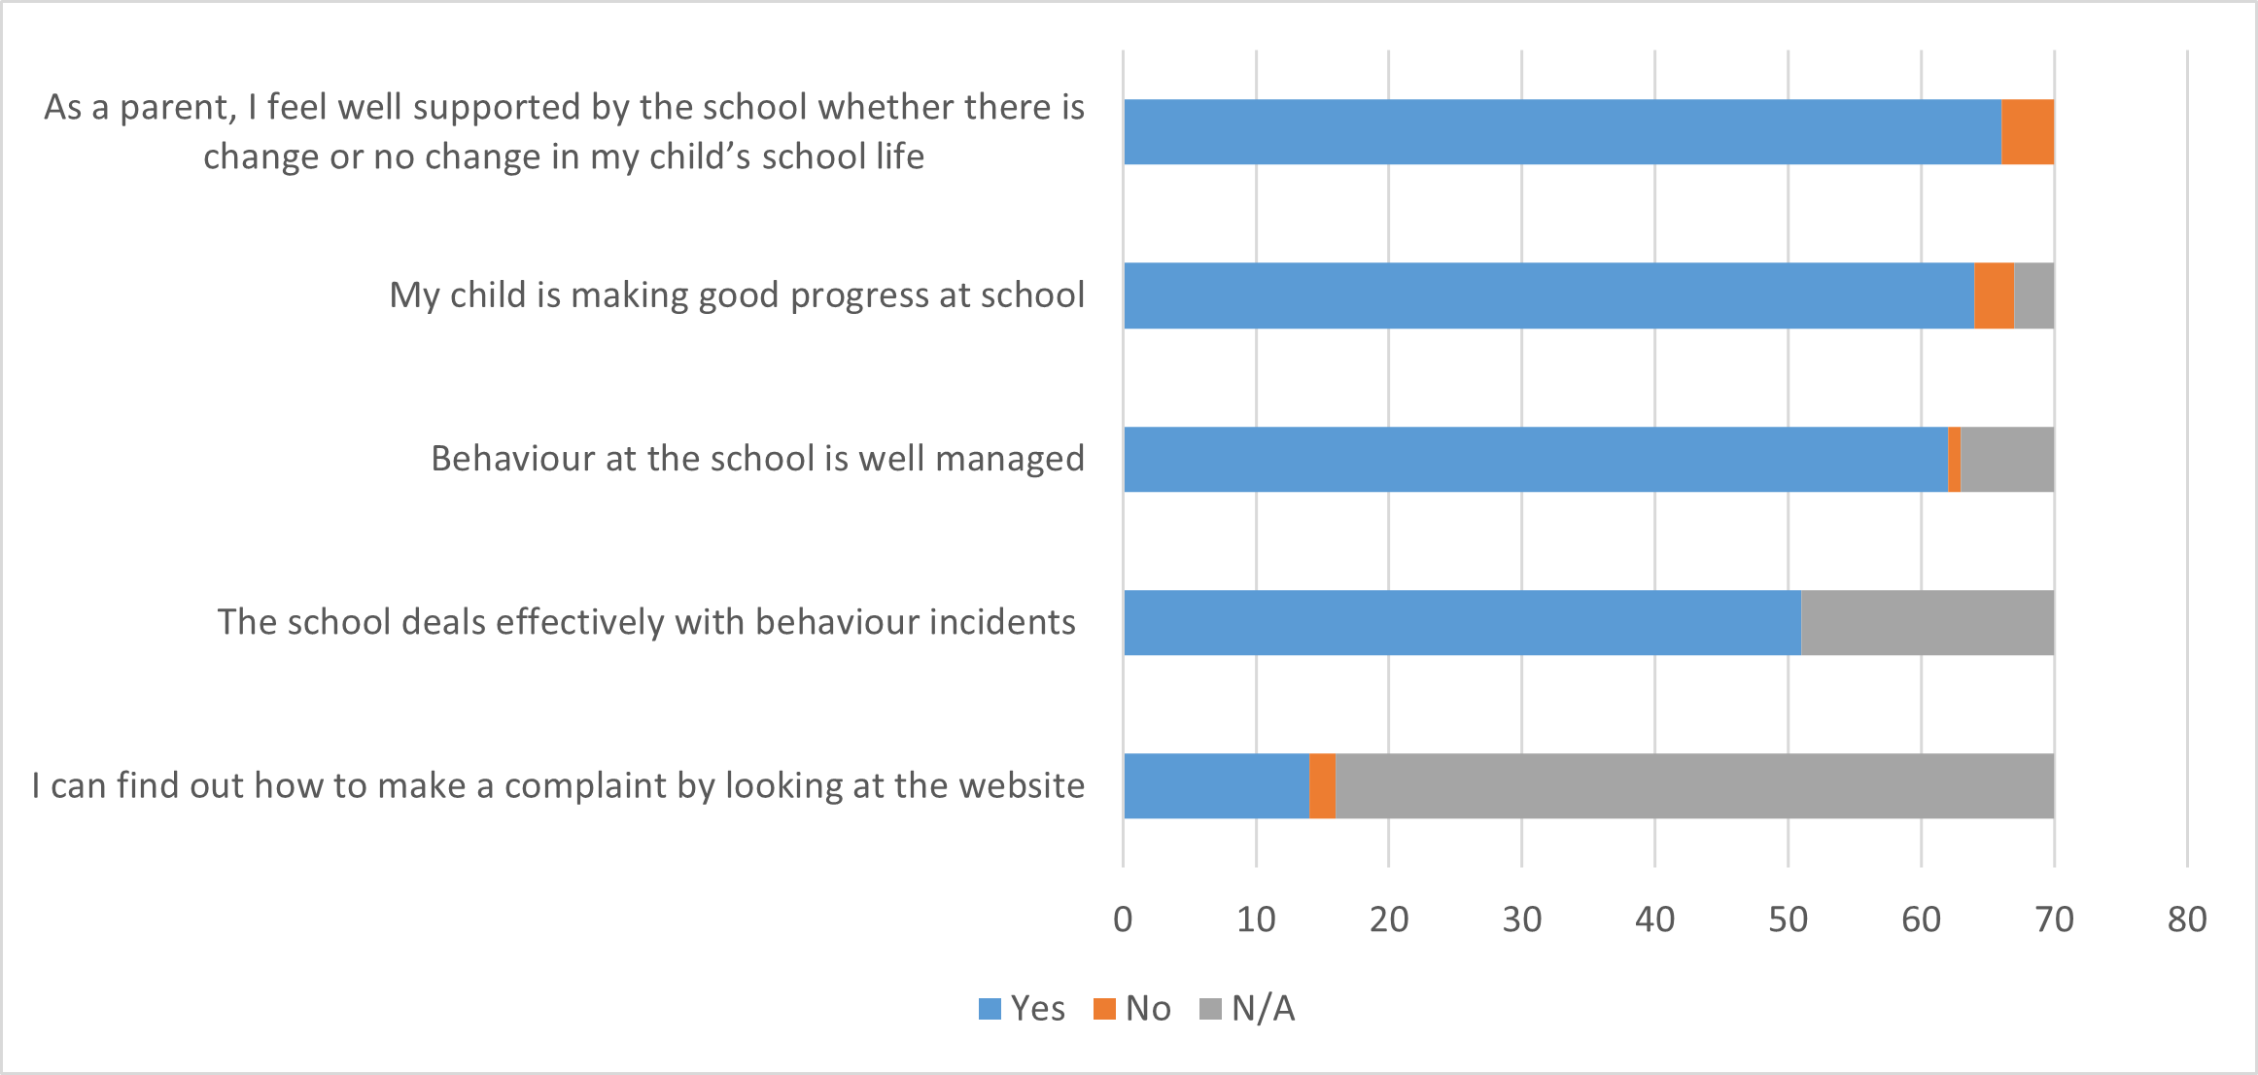

The parent survey was sent out electronically by Microsoft 365 and as paper copies to capture as many parents as possible. We received 70 responses in total. Several families identified needing support with continence and toilet training. Both our Family Support Team and Oxleas dedicated continence nurse can support. You can contact the continence nurse at oxl-tr.cypinclusionteam@nhs.net or call into school to speak to our Family Support Team.
As a school we are continually looking for ways to improve. It is important that if you think we can do better, that you let us know so we can take measures to do so. We would welcome any further comments or feedback from you, especially if you answered ‘not very often’ or ‘almost never’ to any questions we would really like to hear from you to discuss further. This can be done via the school email address: wdcontact@willowdene.compassps.uk, by telephone 02088549841 or by contacting Rachel directly for a meeting.

